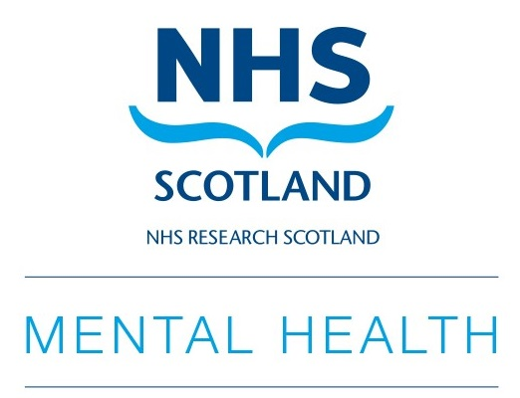

NRS Mental Health Network

Annual Scientific Meeting

30th October 2025

(Hybrid event)

Technology & Innovation Centre, University of Strathclyde

Poster Submission Guidelines

Poster abstract submission due by 5pm 10th October 2025.

Please keep your abstract at approx. 300 words in total.

All posters around the theme of mental health research are welcome

Posters outlining work that is in progress but has not been completed are welcome

Posters must be submitted in portrait format (A0).

Poster abstracts will be reviewed and presenters will be notified by email if successful.

There are poster prizes available in two categories: student and post doc/established

Please complete and return the form below to Lisa Martin at lisa.y.martin@ed.ac.uk

Presenter name
Position
Organisation
Email address
Poster Title
Authors and Affiliations
Introduction and Aims
Methods
Results
Discussion

